SETTING UP NETWORKING SIMULATION TOOLS AND INSTALLING WIRESHARK FOR NETWORK TRAFFIC ANALYSIS
Prepared By
Samuel Ochoche Peter
Cybersecurity Student
3MTT Cybersecurity Program
1. Introduction
Network traffic analysis is an essential skill in cybersecurity, network administration, and digital forensics. Organizations use packet analysis tools to monitor communications, detect malicious activities, troubleshoot connectivity issues, and understand how protocols operate within a network.
This project focuses on the installation and configuration of Wireshark, a widely used network protocol analyzer, and the use of packet capture techniques to inspect live network traffic. The project also demonstrates protocol identification and analysis using real network communications.
2. Project Overview
The purpose of this project was to establish a network monitoring environment capable of capturing and analyzing data packets traversing a network.
The project introduced the use of Wireshark to:
- Capture network packets.
- Analyze communication protocols.
- Observe network behavior.
- Perform basic troubleshooting.
- Develop practical cybersecurity monitoring skills.
3. Project Objectives
The objectives of this project were:
- Install Wireshark successfully.
- Configure packet capture drivers.
- Identify active network interfaces.
- Capture live network traffic.
- Analyze common protocols.
- Understand packet structure.
- Gain practical experience with cybersecurity monitoring tools.
4. Scope of the Project
This project falls under:
Cybersecurity Monitoring and Network Traffic Analysis
The scope includes:
- Network packet capture.
- Protocol analysis.
- Security monitoring.
- Network troubleshooting.
- Traffic inspection.
The project does not involve offensive security activities or penetration testing.
5. Tools and Software Used
Tool | Purpose
Wireshark 4.6.6 | Packet Capture and Analysis
Npcap | Packet Capture Driver
Windows Operating System | Host Environment
Network Adapter (Wi-Fi 2) | Traffic Source

6. Assets, Threats, and Vulnerabilities
Assets
The following assets were identified:
- Computer System
- Wi-Fi Network Adapter
- Network Traffic
- Internet Connectivity
- Packet Capture Files
Threats
Potential threats include:
- Packet sniffing
- Man-in-the-middle attacks
- Data interception
- Unauthorized monitoring
- Malware communications
Vulnerabilities
Potential vulnerabilities include:
- Unencrypted traffic
- Weak network configurations
- Lack of monitoring
- Misconfigured systems

7. Wireshark Installation and Configuration
Wireshark was downloaded from the official Wireshark website and installed successfully.
The installation included:
- Wireshark Network Analyzer
- Npcap Packet Capture Driver
- Protocol Support Components
The installation process completed successfully without errors.
Screenshot 1
Wireshark Download Page
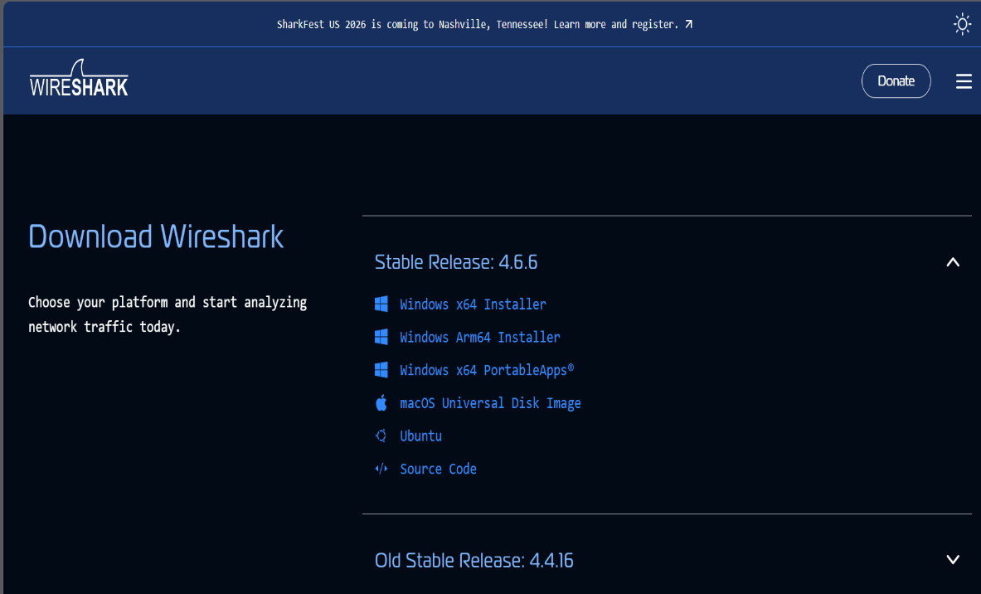

Screenshot 2
Downloaded Wireshark Installer
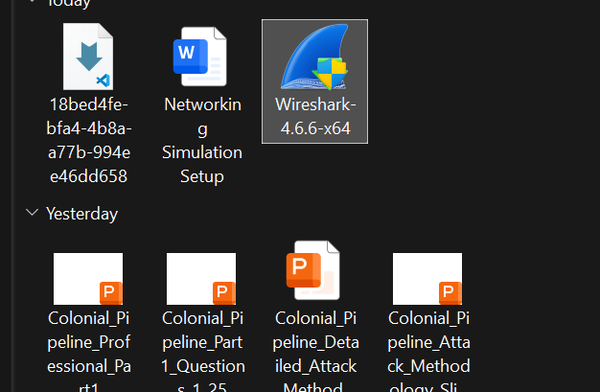

Screenshot 3
Wireshark Installation Wizard

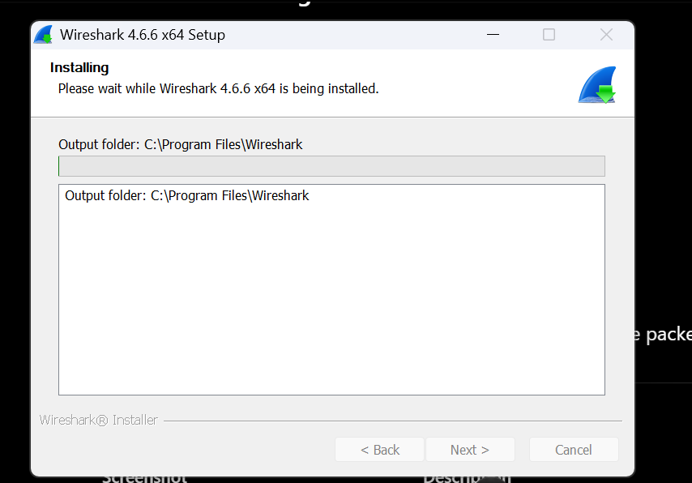

Screenshot 4
Npcap Configuration

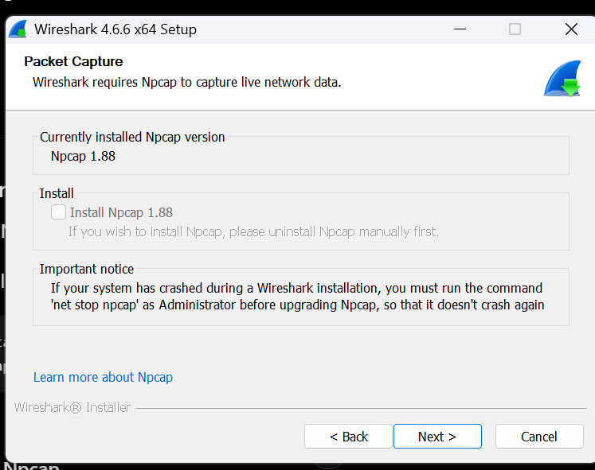

Screenshot 5
Installation Completed Successfully
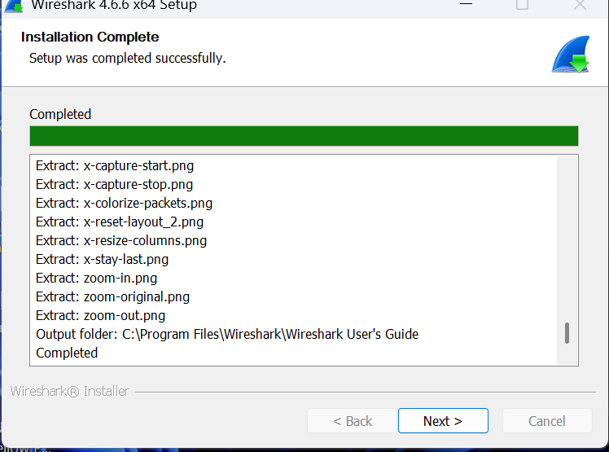

8. Network Interface Detection
After launching Wireshark, several network interfaces were detected.
The primary active interface used for packet capture was:
Wi-Fi 2
This interface showed active traffic and was selected for monitoring.
Screenshot 6
Available Network Interfaces in Wireshark
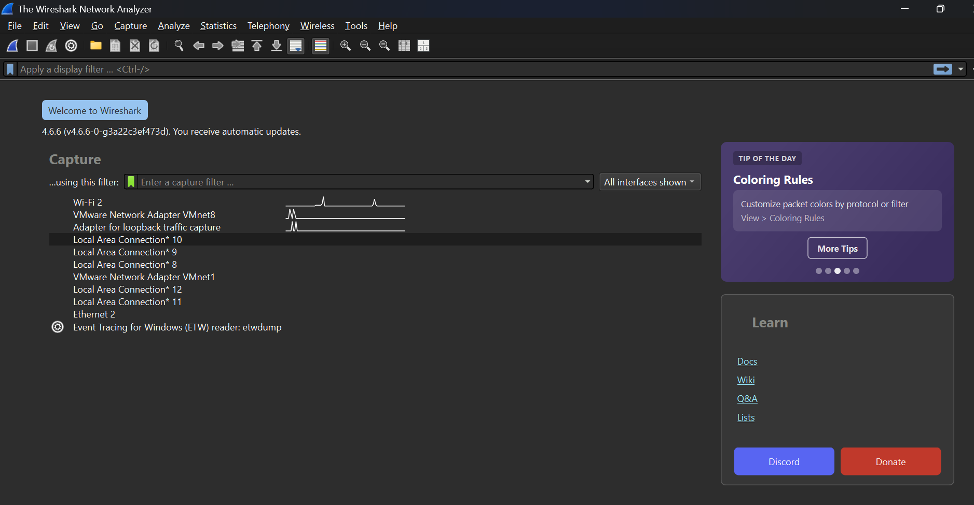

9. Live Packet Capture
A live packet capture session was initiated on the Wi-Fi 2 network adapter.
Traffic was generated through normal internet activities such as:
- Web browsing
- DNS lookups
- Background network communications
Wireshark successfully captured and displayed packets in real time.
Screenshot 7
Live Packet Capture
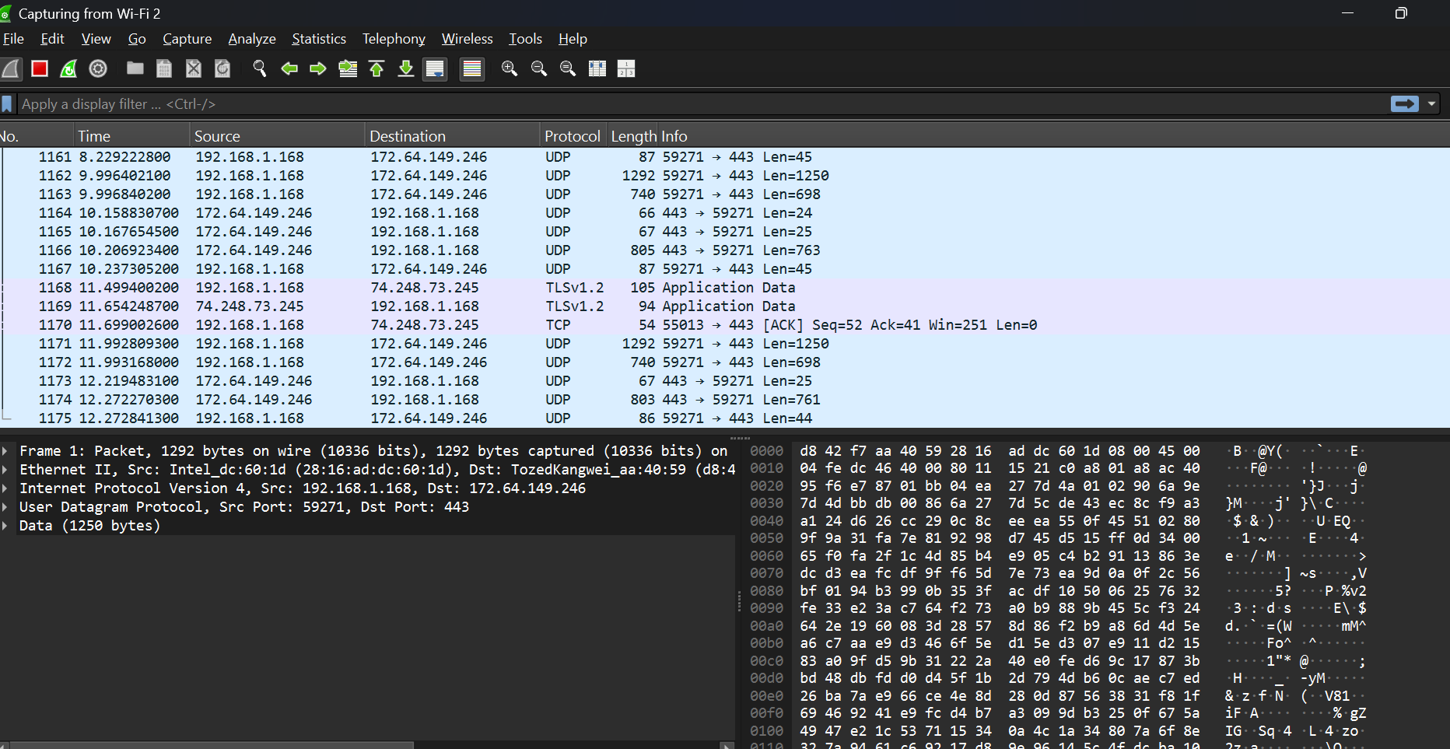

10. Protocol Analysis
During the capture process, several protocols were observed.
10.1 DNS Analysis
Protocol
DNS (Domain Name System)
Purpose
DNS converts domain names into IP addresses.
Example:
google.com
↓
74.125.128.84
Observed DNS traffic included:
- DNS Queries
- DNS Responses
- Hostname Resolution
Screenshot 8
DNS Traffic Analysis
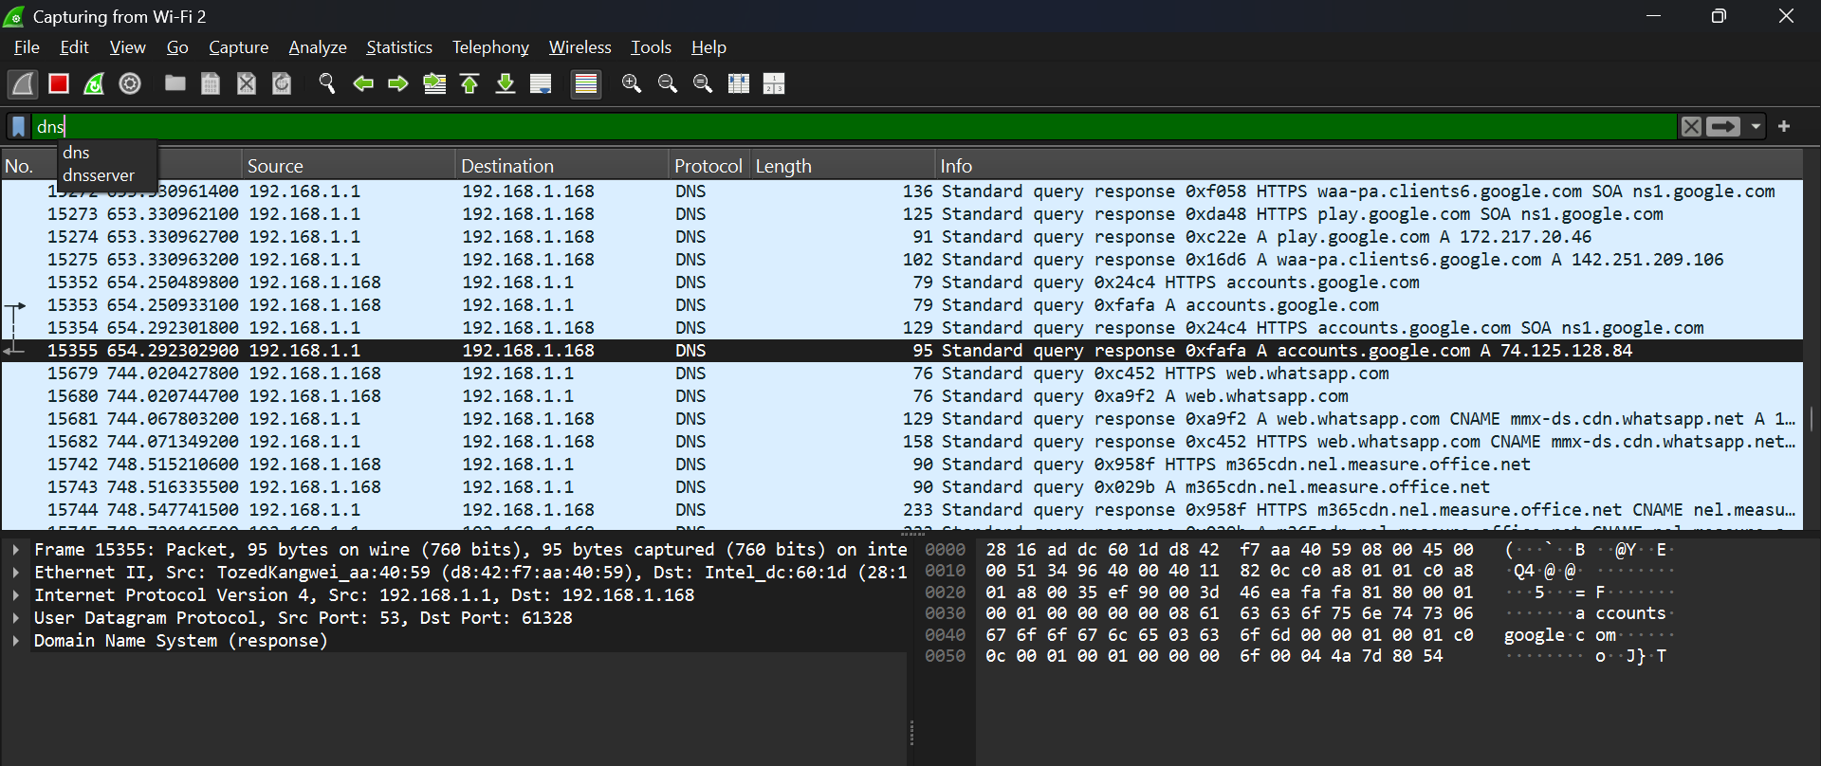
Security Importance
DNS monitoring helps identify:
- Malicious domains
- Command and Control Servers
- DNS Tunneling
10.2 ICMP Analysis
Protocol
ICMP (Internet Control Message Protocol)
Purpose
Used for:
- Ping Requests
- Ping Replies
- Network Diagnostics
Observed traffic included:
- Echo Requests
Screenshot 9
ICMP Traffic Analysis
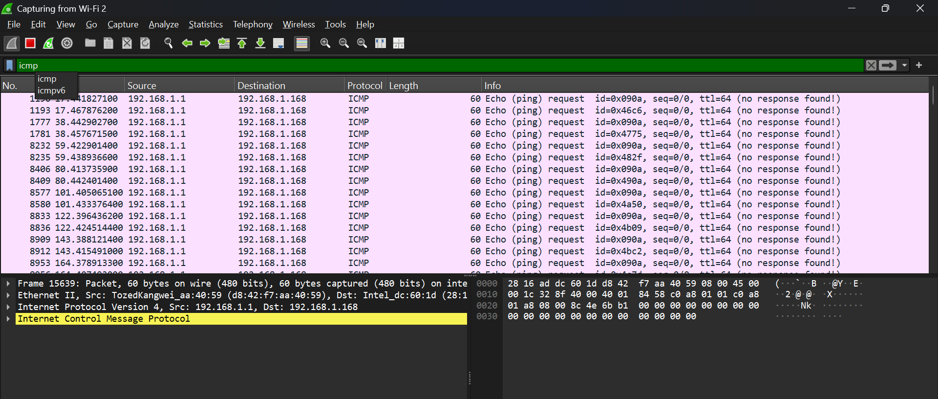
Security Importance
ICMP is useful for:
- Network troubleshooting
- Host discovery
- Availability testing
Attackers may also use ICMP for reconnaissance.
10.3 TCP Analysis
Protocol
TCP (Transmission Control Protocol)
Purpose
Provides reliable communication between devices.
Observed TCP activities included:
- TCP Handshake
- ACK Packets
- Secure Communications
Screenshot 10
TCP Traffic Analysis
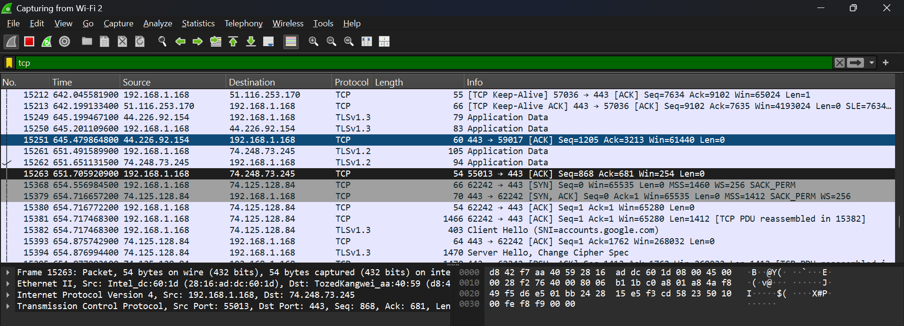

Security Importance
TCP analysis helps identify:
- Connection establishment
- Network anomalies
- Suspicious communications
11. Security Monitoring Findings
The following protocols were identified during analysis:
Protocol | Purpose
TCP | Reliable communication
DNS | Name resolution
ICMP | Connectivity testing
TLS | Secure encrypted communication
UDP | Fast communication transport
The captured traffic demonstrated normal network behavior.
No suspicious traffic was observed during the capture session.
12. Testing and Validation
The following tests were successfully completed:
Test | Result
Wireshark Installation | PASS
Npcap Installation | PASS
Interface Detection | PASS
Live Packet Capture | PASS
DNS Analysis | PASS
ICMP Analysis | PASS
TCP Analysis | PASS

13. Cybersecurity Relevance
Wireshark is widely used by:
- Security Analysts
- SOC Analysts
- Network Engineers
- Penetration Testers
- Incident Response Teams
The tool assists in:
- Threat Hunting
- Malware Investigation
- Traffic Analysis
- Intrusion Detection
- Network Troubleshooting
14. Conclusion
The project successfully established a network monitoring environment using Wireshark. Live network traffic was captured and analyzed through the Wi-Fi network interface. Multiple protocols including DNS, ICMP, TCP, UDP, and TLS were identified and examined.
The project provided practical experience in packet capture, protocol analysis, and cybersecurity monitoring. These skills are essential for cybersecurity professionals involved in network security, incident response, digital forensics, and security operations.

